Machine learning Lab Observation
ITA0614
Experiment 2
For a given set of training data examples stored in a .CSV file, implement and demonstrate the Candidate-Elimination algorithm in python to output a description of the set of all hypotheses consistent with the training examples.
Name : Sakthi K S
Reg.No : 192412247
Problem 1 : Play Tennis
Aim
To implement the Candidate-Elimination algorithm on the PlayTennis training data stored in a .CSV file and output the S and G boundary sets of the version space.
Algorithm
- Initialise G to the maximally general hypothesis, <?, ?, ..., ?>, and S to the maximally specific hypothesis, <0, 0, ..., 0>.
- For each training example d:
If d is a positive example: remove from G every hypothesis inconsistent with d. For each s in S that is inconsistent with d, remove s and add all minimal generalisations h of s such that h is consistent with d and some member of G is more general than h. Remove from S any hypothesis that is more general than another hypothesis in S.
If d is a negative example: remove from S every hypothesis inconsistent with d. For each g in G that is inconsistent with d, remove g and add all minimal specialisations h of g such that h is consistent with d and some member of S is more specific than h. Remove from G any hypothesis that is less general than another hypothesis in G.
- Output the boundary sets S and G (the version space lies between them).
Program:
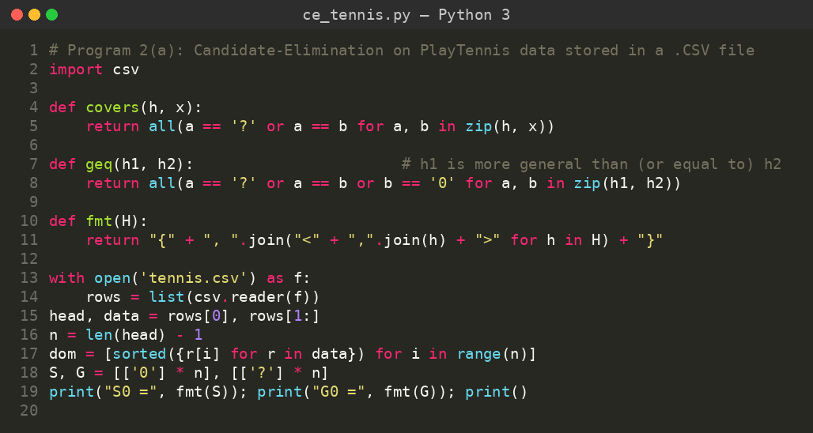
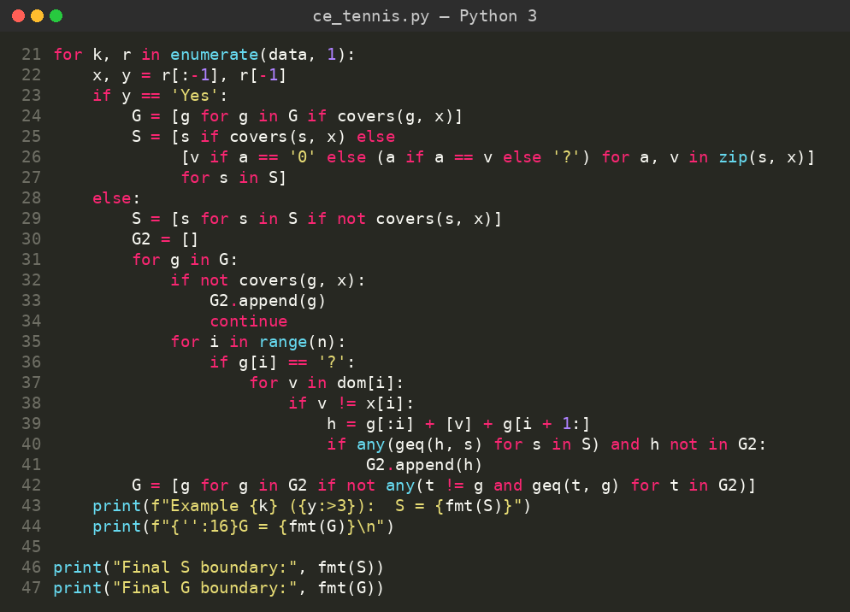
Input
PlayTennis data set (tennis.csv): 6 examples, 4 attributes (Outlook, Temp, Humidity, Wind) and the target concept PlayTennis (Yes / No). The attribute domains are taken automatically from the file.
Outlook | Temp | Humidity | Wind | PlayTennis
Sunny | Hot | Normal | Weak | Yes
Sunny | Mild | Normal | Strong | Yes
Rain | Cool | High | Strong | No
Overcast | Hot | High | Weak | No
Sunny | Cool | Normal | Weak | Yes
Sunny | Hot | High | Weak | No
Output
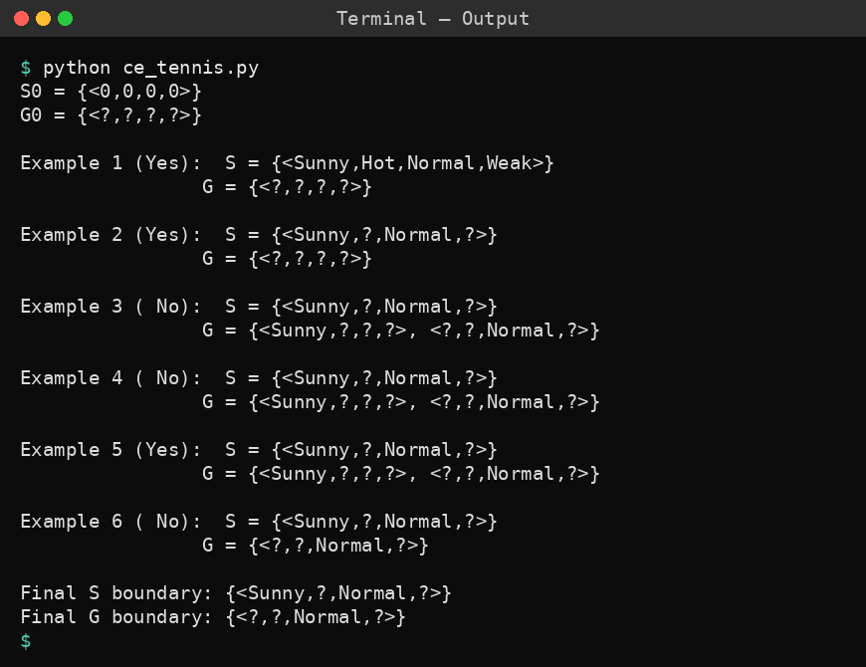
Result
The version space for the PlayTennis data is bounded by S = {<Sunny, ?, Normal, ?>} and G = {<?, ?, Normal, ?>}. After the third example G holds <Sunny, ?, ?, ?> and <?, ?, Normal, ?>, but <Sunny, ?, ?, ?> is removed after the sixth example because it covers the negative example (Sunny, Hot, High, Weak). The version space therefore contains the two hypotheses <Sunny, ?, Normal, ?> and <?, ?, Normal, ?>.
Problem 2: Spam e-mail detection
Aim
To implement the Candidate-Elimination algorithm using the pandas library on an e-mail data set and to find the boundary sets S and G.
Algorithm
- Initialise G to the maximally general hypothesis, <?, ?, ..., ?>, and S to the maximally specific hypothesis, <0, 0, ..., 0>.
- For each training example d:
If d is a positive example: remove from G every hypothesis inconsistent with d. For each s in S that is inconsistent with d, remove s and add all minimal generalisations h of s such that h is consistent with d and some member of G is more general than h. Remove from S any hypothesis that is more general than another hypothesis in S.
If d is a negative example: remove from S every hypothesis inconsistent with d. For each g in G that is inconsistent with d, remove g and add all minimal specialisations h of g such that h is consistent with d and some member of S is more specific than h. Remove from G any hypothesis that is less general than another hypothesis in G.
- Output the boundary sets S and G (the version space lies between them).
Program:
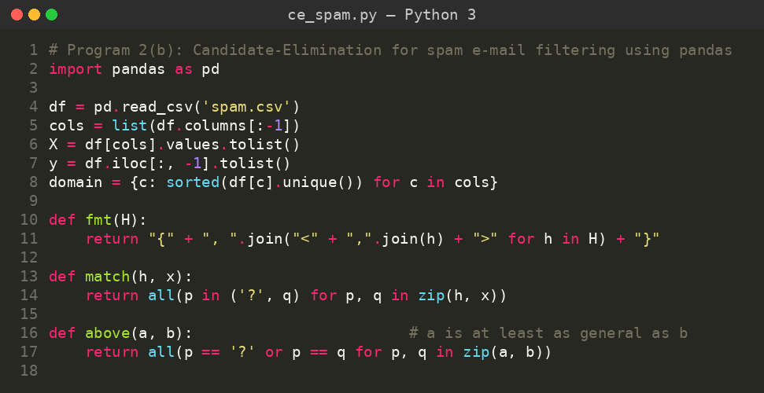
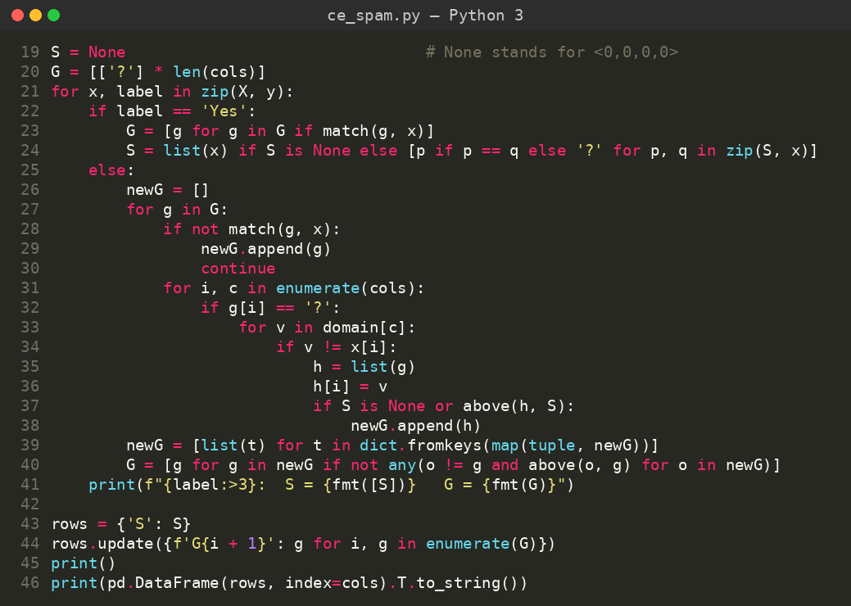
Input
E-mail data set (spam.csv): 5 examples, 4 attributes (HasLink, HasAttachment, KnownSender, AllCaps) and the target concept IsSpam (Yes / No), loaded as a pandas DataFrame.
HasLink | HasAttachment | KnownSender | AllCaps | IsSpam
Yes | No | No | Yes | Yes
Yes | Yes | No | Yes | Yes
No | No | Yes | No | No
Yes | No | No | No | Yes
No | Yes | Yes | No | No
Output
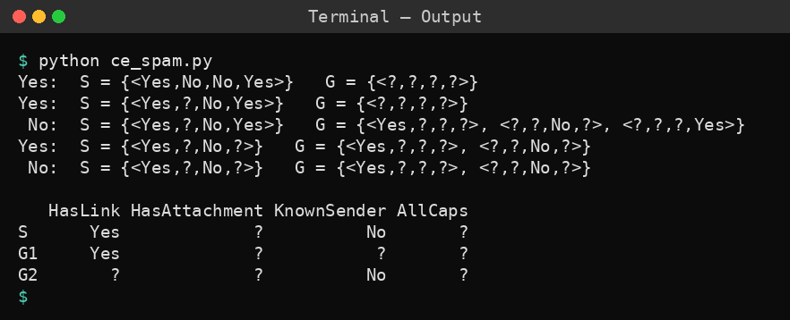
Result
After processing all five examples the boundaries are S = {<Yes, ?, No, ?>} and G = {<Yes, ?, ?, ?>, <?, ?, No, ?>}. G contains <?, ?, ?, Yes> after the third example, but it is removed after the fourth example because it is inconsistent with the positive example whose AllCaps value is No. The version space contains the three hypotheses <Yes, ?, No, ?>, <Yes, ?, ?, ?> and <?, ?, No, ?>.
Problem 3: Flu diagnosis
Aim
To implement the Candidate-Elimination algorithm in the commonly used form in which S is initialised with the first positive training example, using flu diagnosis data from a .CSV file.
Algorithm
- Initialise S to the first positive training example and G to the maximally general hypothesis, <?, ?, ..., ?>.
- For each training example d:
If d is a positive example: remove from G every hypothesis inconsistent with d. For each s in S that is inconsistent with d, remove s and add all minimal generalisations h of s such that h is consistent with d and some member of G is more general than h. Remove from S any hypothesis that is more general than another hypothesis in S.
If d is a negative example: remove from S every hypothesis inconsistent with d. For each g in G that is inconsistent with d, remove g and add all minimal specialisations h of g such that h is consistent with d and some member of S is more specific than h. Remove from G any hypothesis that is less general than another hypothesis in G.
- Output the boundary sets S and G (the version space lies between them).
Program:
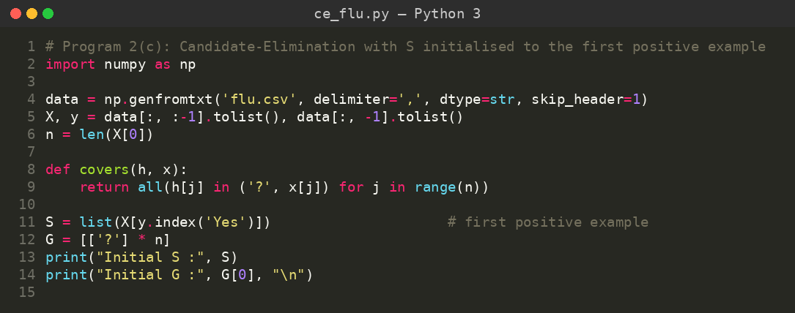
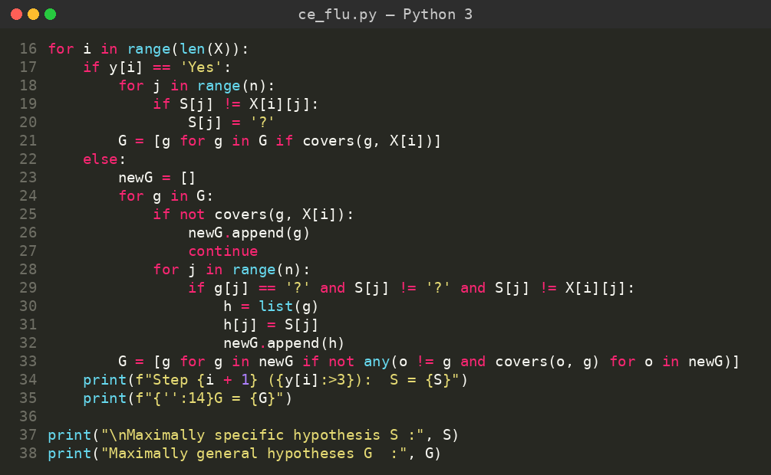
Input
Flu data set (flu.csv): 5 examples, 4 attributes (Fever, Cough, Fatigue, Breathing) and the target concept Flu (Yes / No). The first row of data is a positive example.
Fever | Cough | Fatigue | Breathing | Flu
High | Dry | Yes | Normal | Yes
High | Dry | Yes | Hard | Yes
Normal | Wet | No | Normal | No
High | Dry | No | Normal | Yes
Normal | Dry | No | Hard | No
Output
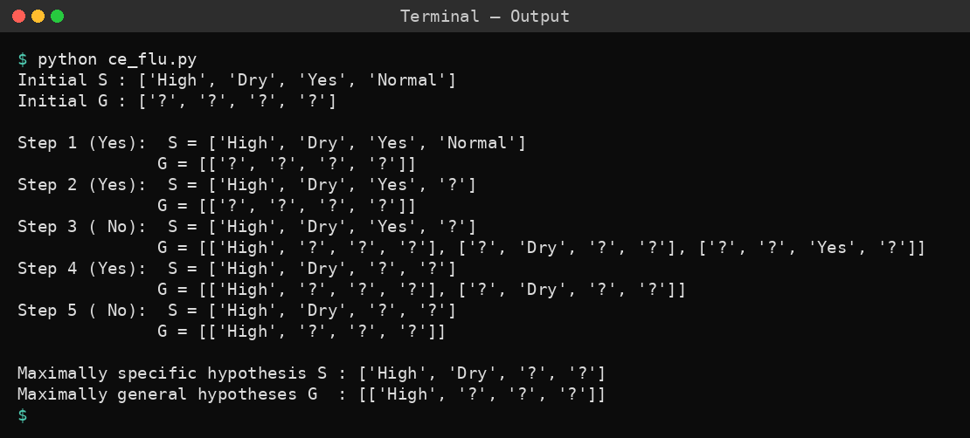
Result
The boundaries converge to S = {<High, Dry, ?, ?>} and G = {<High, ?, ?, ?>}. The hypotheses <?, ?, Yes, ?> and <?, Dry, ?, ?> are removed from G after the fourth and fifth examples respectively because they are inconsistent with the later data. The version space contains exactly two hypotheses, <High, Dry, ?, ?> and <High, ?, ?, ?>, so a high fever is the deciding symptom for flu in this data.
Problem 4: Car purchase
Aim
To implement Candidate-Elimination as a Python class and to enumerate every hypothesis of the version space that lies between the S and G boundaries.
Algorithm
- Initialise G to the maximally general hypothesis, <?, ?, ..., ?>, and S to the maximally specific hypothesis, <0, 0, ..., 0>.
- For each training example d:
If d is a positive example: remove from G every hypothesis inconsistent with d. For each s in S that is inconsistent with d, remove s and add all minimal generalisations h of s such that h is consistent with d and some member of G is more general than h. Remove from S any hypothesis that is more general than another hypothesis in S.
If d is a negative example: remove from S every hypothesis inconsistent with d. For each g in G that is inconsistent with d, remove g and add all minimal specialisations h of g such that h is consistent with d and some member of S is more specific than h. Remove from G any hypothesis that is less general than another hypothesis in G.
- Output the boundary sets S and G (the version space lies between them).
Program:
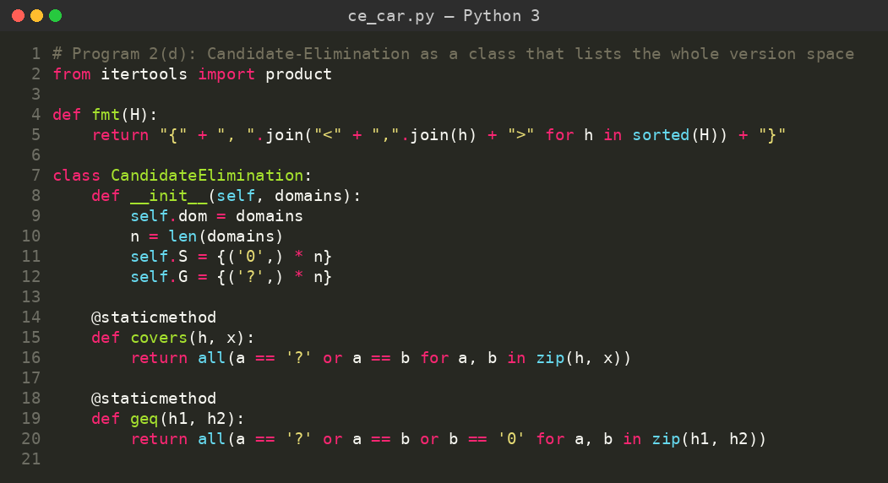
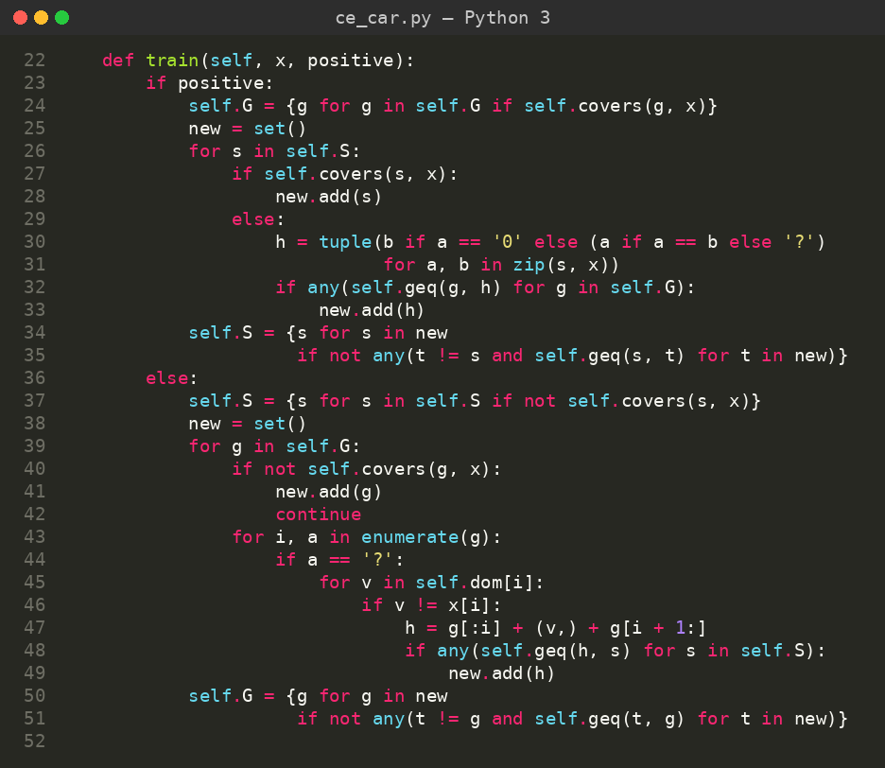
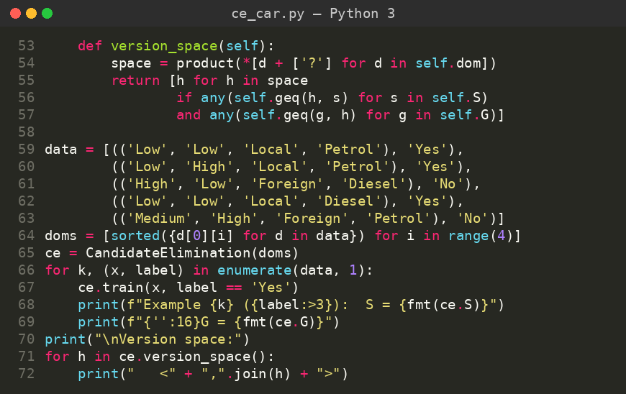
Input
Car purchase data set: 5 examples, 4 attributes (Price, Mileage, Brand, Fuel) and the target concept Buy (Yes / No). The data is stored in the program as tuples.
Price | Mileage | Brand | Fuel | Buy
Low | Low | Local | Petrol | Yes
Low | High | Local | Petrol | Yes
High | Low | Foreign | Diesel | No
Low | Low | Local | Diesel | Yes
Medium | High | Foreign | Petrol | No
Output
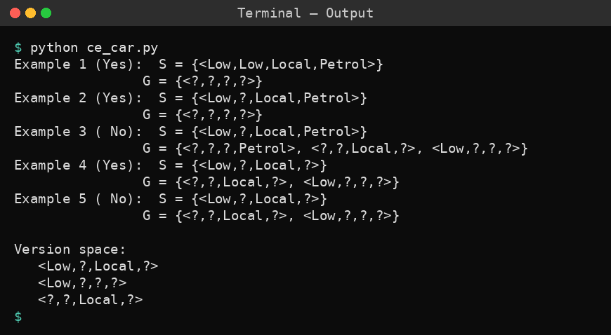
Result
The final boundaries are S = {<Low, ?, Local, ?>} and G = {<?, ?, Local, ?>, <Low, ?, ?, ?>}. The version space contains exactly three hypotheses: <Low, ?, Local, ?>, <Low, ?, ?, ?> and <?, ?, Local, ?>.
Problem 5: Buys computer
Aim
To apply the Candidate-Elimination algorithm to customer data (Buys-Computer) and to use the S and G boundaries to classify new samples.
Algorithm
- Initialise G to the maximally general hypothesis, <?, ?, ..., ?>, and S to the maximally specific hypothesis, <0, 0, ..., 0>.
- For each training example d:
If d is a positive example: remove from G every hypothesis inconsistent with d. For each s in S that is inconsistent with d, remove s and add all minimal generalisations h of s such that h is consistent with d and some member of G is more general than h. Remove from S any hypothesis that is more general than another hypothesis in S.
If d is a negative example: remove from S every hypothesis inconsistent with d. For each g in G that is inconsistent with d, remove g and add all minimal specialisations h of g such that h is consistent with d and some member of S is more specific than h. Remove from G any hypothesis that is less general than another hypothesis in G.
- Output the boundary sets S and G (the version space lies between them).
Program:
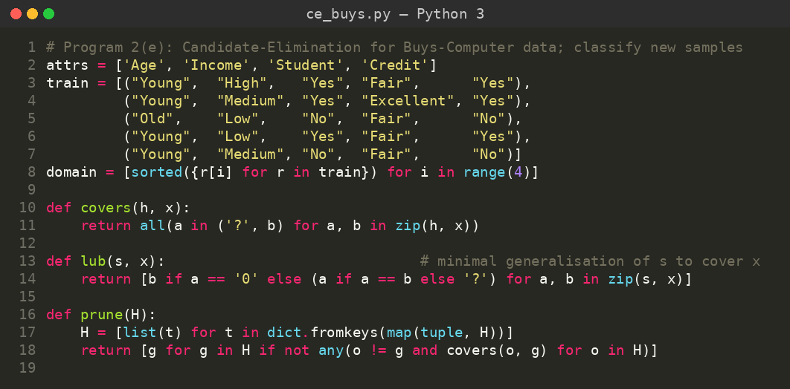
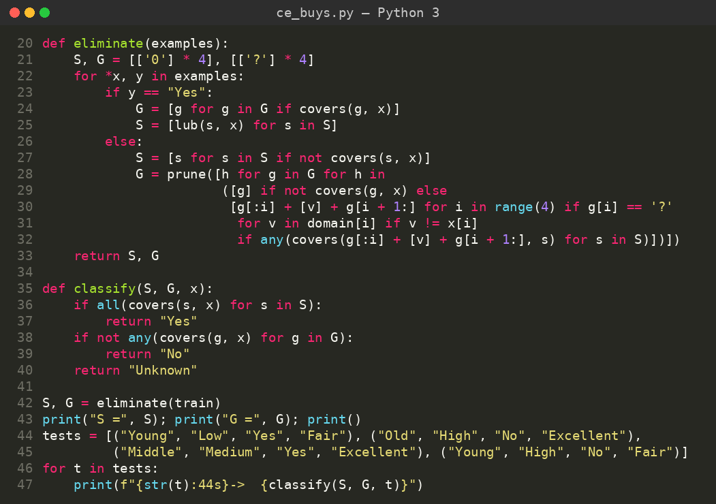
Input
Buys-Computer data set: 5 examples, 4 attributes (Age, Income, Student, Credit) and the target concept Buys (Yes / No).
Age | Income | Student | Credit | Buys
Young | High | Yes | Fair | Yes
Young | Medium | Yes | Excellent | Yes
Old | Low | No | Fair | No
Young | Low | Yes | Fair | Yes
Young | Medium | No | Fair | No
Output
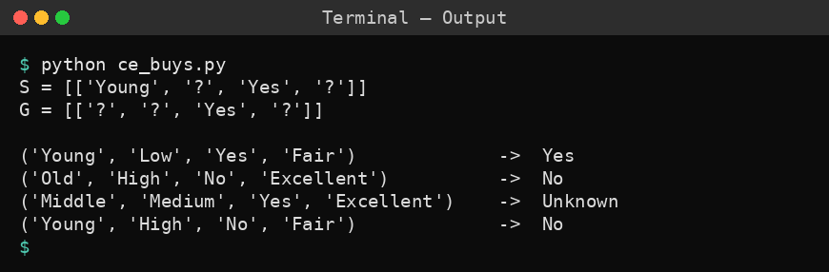
Result
The boundaries obtained are S = {<Young, ?, Yes, ?>} and G = {<?, ?, Yes, ?>}. Using them, (Young, Low, Yes, Fair) is classified Yes, (Old, High, No, Excellent) is classified No and (Young, High, No, Fair) is classified No, while (Middle, Medium, Yes, Excellent) cannot be classified with certainty because the hypotheses of the version space disagree.

